EXIT: The Wilderness ENTER: The Promised Land of Canaan TIME: 13th Century B.C.E. (Approximately). Considered a sequel to Deuteronomy and was intended to be read with it. First book of The Deuteronomistic History (Deuteronomy – Kings).
NOTE: The writing of the book took place much later and thus the book reflects the theological concerns of later times. Those later times include:
- King Josiah’s reign (late 7th century) (2 Kings 22-23)
  - Josiah’s strong concern for religious purity and absolute devotion to God.
- The destruction of Jerusalem (587 BCE) and the return from exile (539 BCE)
  - When the book was completed.
  - So the book context includes the trauma of exile and Israel’s identity crisis.
In the Jewish Cannon: it is considered the first book of the “Former Prophets” (Joshua through Kings). The “Latter Prophets” follow the books of Isaiah through Malachi.
In the Christian Cannon: Joshua is part of a grand narrative that runs from Genesis 12 to Esther (from Creation to Exile).
Joshua = “The Lord Saves.” A reminder that the Lord would lead and protect the people as they entered Canaan.
- Military leader who fought the Amelkites (Exo. 17:8-16)
- Became Moses’ assistant during the wilderness
- Appointed by Moses to become his successor
Moses- Moses’ authority and influence continues (refer to the Instruction Scrolls)
Eleazar and Phineas- priest and his son- featured prominently in Joshua 14-19. It is Phineas (not Joshua) whom the Western Israelites send to settle dispute with Eastern Israelites
FACTOID: ***The name “Jesus” is Greek for “Joshua.”***
OUTLINE:
- Conquest of the land (Chapters 1-12)
- The division of the land to some of the tribes (13-22)
- The call to the people to repent and renew the covenant (23-24)
- Death and Burial (24)
REMINDER: The land was a gift from God. Keeping the land depended on the people being faithful to God.
PJ’s PICKS
Rahab (2:1-21)
- Rahab is identified as a prostitute. Prostitution for economic survival was practiced (Prov. 6:26).
- It is NOT clear if the spies came to Rahab as her customers. (“They bedded down there” implies sexual activity).
- She was an ancestor of King David (Matthew 1:5) and this story explains how she and her family survived the conquest of Jericho.
- She is praised as a person of great faith (Hebrews 11:31). Her awareness of God’s power sets her apart from most of the other Canaanites.
- She is justified by the act of harboring the spies (James 2:25).
Unlike in Numbers 13, God did not send the spies. This was on Joshua. Possibly why it failed. Why it failed? The spies came to uncover secrets and be undetected, but are found out and have to hide in the house of a prostitute. They are always in danger of being seen by city officials. And they hide on a rooftop which is not the best place.
Jericho is located about 10 miles north of the Dead Sea and just west of the Jordan River and 17 miles east of Jerusalem. FACTOID: it is the oldest continuously populated city in the world, established around 9000 BCE.
The “mini-Passover” sign- the red woven cord to be the signal for the warriors to stay clear of Rahab’s house.
RE(E)D SEA- a marshy area far west of the Red Sea. The Septuagint mistakes the crossing of the Israelites as the Red Sea.
The Crossing of the Jordan (3:1-13)
The entire population of the land has melted down in fear because of you.” “Heart melts” count: 2:9, 2:24; 5:1, 7:5 (this time it’s Israel), 14:8 (Israel) (23:10 A single one of you puts a thousand to flight. This is because the Lord your God fights for you, exactly as he promised you)
3:10-Then Joshua said, “This is how you will know that the living God is among you and will completely remove the Canaanites, Hittites, Hivites, Perizzites, Girgashites, Amorites, and Jebusites before you.” Living God appears only EIGHT times in the OT. It refers to the power of God which delivered Israel and gave it possession of Canaan.
The 12 Stones of Gilgal (4:1-9) 12 stones for 12 tribes. “Do this in remembrance…”

Circumcision and Passover (5:2-9)- two rituals that became very important during the Babylonian Exile. This marks the first Passover in their land.
FACTOID: “Gilgal” in Hebrew means “to roll,” so the disgrace of Egypt is rolled away.
The commander of the Lord’s heavenly force (5:13-15) A divine messenger who represents God’s hope to bring justice to the earth (not just for Israel).
The Walls of Jericho come Tumblin’ Down (6:20): Total destruction
WARNING (6:18-7:26)- This is a reminder that Israel does not possess Jericho due to their military capacity but because of God’s power. Oops! Achan done a bad thing! (7:21) “Among the booty I saw a single beautiful robe in the Babylonian style, two hundred shekels of silver, and a single gold bar weighing fifty shekels. I desired them and took them. Now they are hidden in the ground inside my tent, with the silver on the bottom”.
Ch.8 Ai: Round 2: AMBUSH!
Ch. 9 Gibeonites are spared through “trickeration”

Ch. 10-11 Victories in the South and North
10:40-“So Joshua struck at the whole land: the highlands, the arid southern plains, the lowlands, the slopes, and all their kings. He left no survivors. He wiped out everything that breathed as something reserved for God, exactly as the Lord, the God of Israel, had commanded.”
Ch.14:15 “…Then the land rested from war.”
Ch.21:43-45
⁴³ The Lord gave to Israel all the land he had pledged to give to their ancestors. They took it over and settled there. ⁴⁴ The Lord gave them rest from surrounding danger, exactly as he had pledged to their ancestors. Not one of all their enemies held out against them. The Lord gave all their enemies into their power. ⁴⁵ Not one of all the good things that the Lord had promised to the house of Israel failed. Every promise was fulfilled.

22:5 CAREFUL: ⁵ Just be very careful to carry out the commandment and Instruction that Moses the Lord’s servant commanded you. Love the Lord your God. Walk in all his ways and obey his commandments. Hold on to him and serve him with all your heart and being.”
22:9-34- An “Altar”cation!
Ch. 23 and 24:
Joshua’s call for Israel to be devoted completely to God, a call that is also central to the message of the OT. (Also see Exodus 20:1 and Deuteronomy 6:5)
⁵ Just be very careful to carry out the commandment and Instruction that Moses the Lord’s servant commanded you. Love the Lord your God. Walk in all his ways and obey his commandments. Hold on to him and serve him with all your heart and being.”
¹⁴ “Look. I’m now walking on the road to death that all the earth must take. You know with all your heart and being that not a single one of all the good things that the Lord your God promised about you has failed. They were all fulfilled for you. Not a single one of them has failed. ¹⁵ But in the same way that every good thing that the Lord your God promised about you has been fulfilled, so the Lord could bring against you every bad thing as well. He could wipe you out from this fertile land that the Lord your God has given you.

Ch. 24:2-13
REVERE the Lord-
24:19. 22 Is Joshua egging him on? Look at all they did in this book. Joshua is bringing up a lot of old history. But it does serve the purpose of reminding the people of their past (Especially the generation that died in the wilderness).
24:29-33 3 graves
- Joshua (110 years old)
- Joseph (remains)
- Eleazar and Phineas

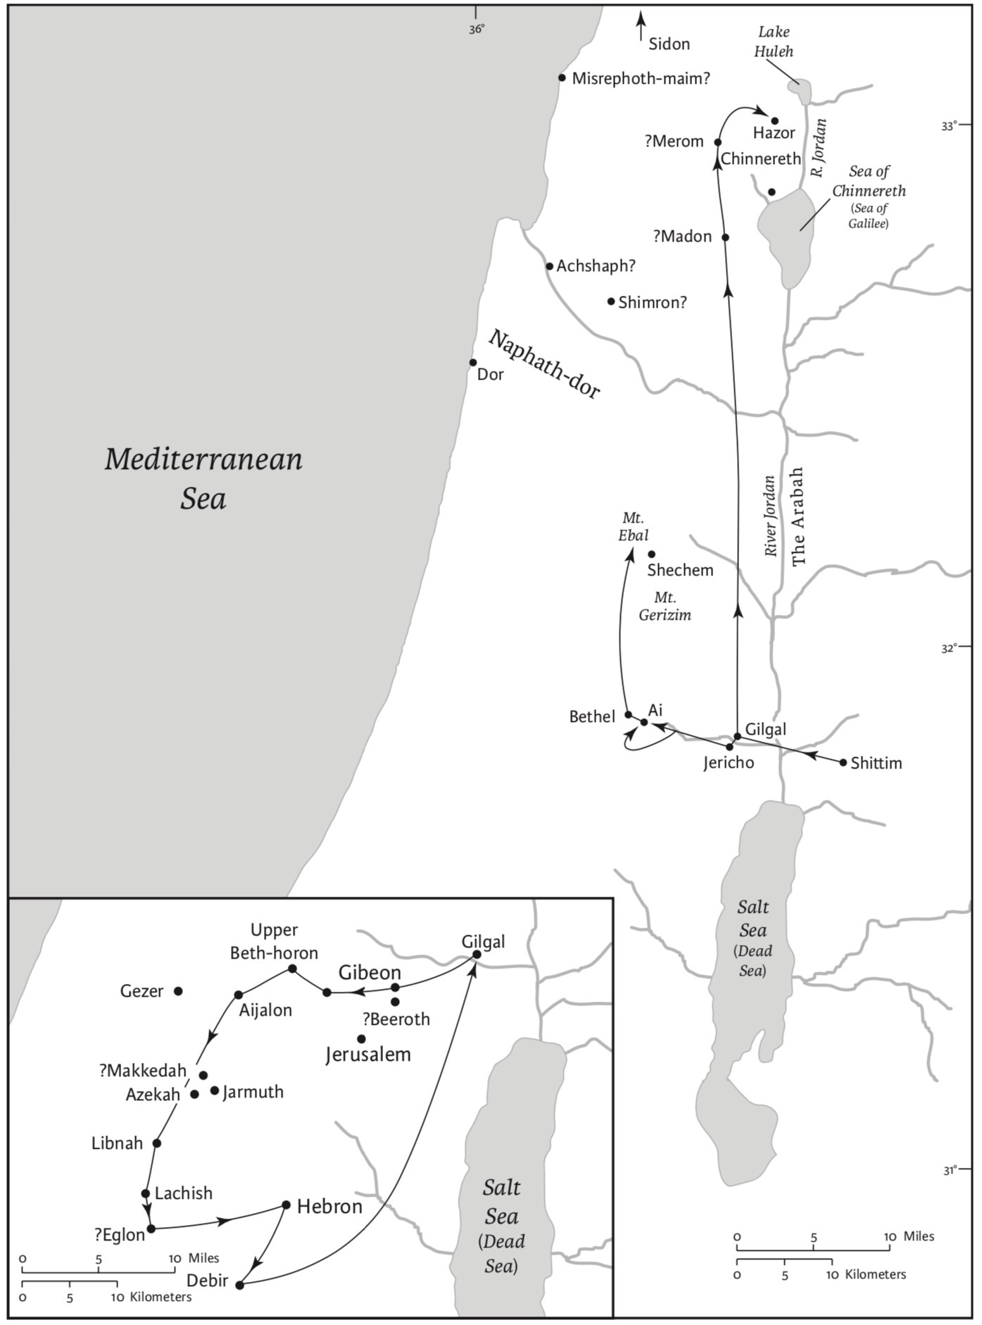
The conquest of Canaan according to the Book of Joshua, chs 3–11
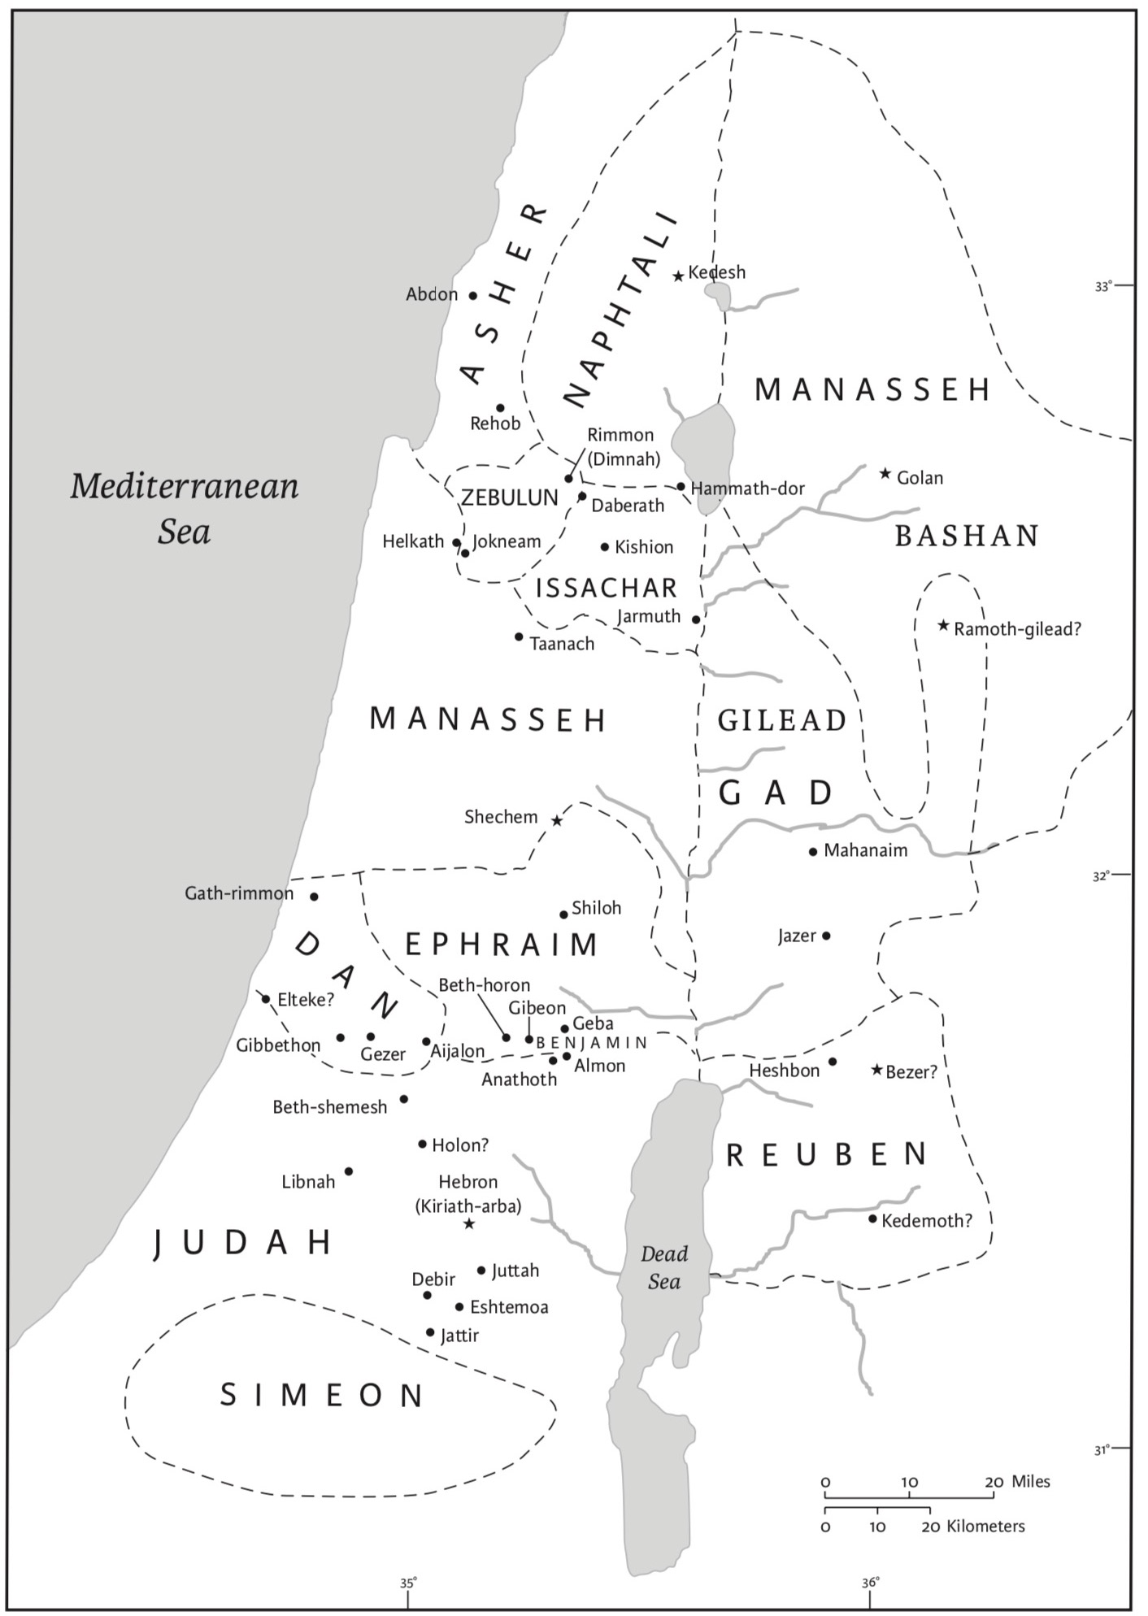
The Levitical cities (21.1–42). Cities of (ch 20) refuge are highlighted with a star.

